Các bước setup database

B1: Mở đồ án lên xong vào XAMPP “start” MySQL và Apache lên.
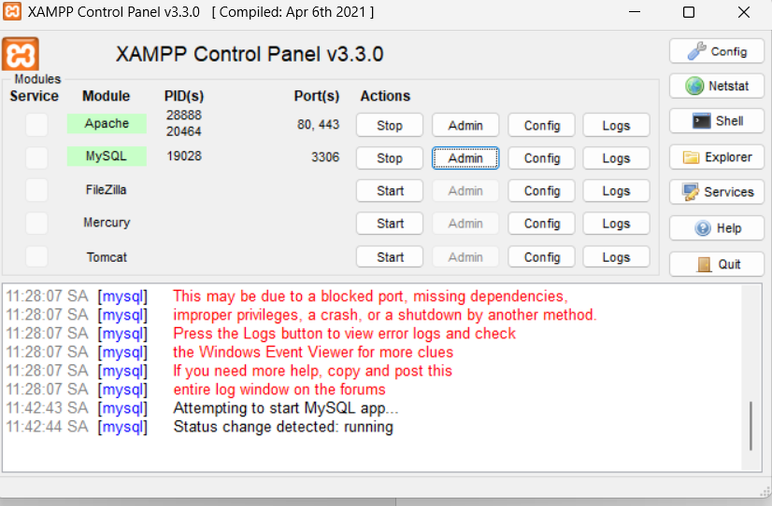

B2: mở terminal trong project rồi gõ lệnh "dotnet ef database update"-->để tạo database cinema_booking_db(chưa có dữ liệu gì cả)
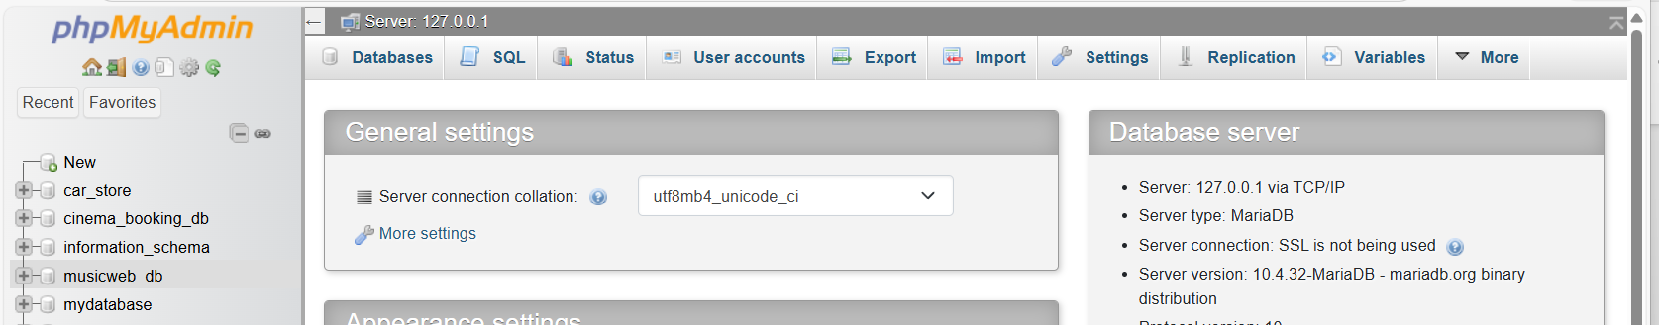

B3:Mở XAMPP lên chọn admin phần MySQL:

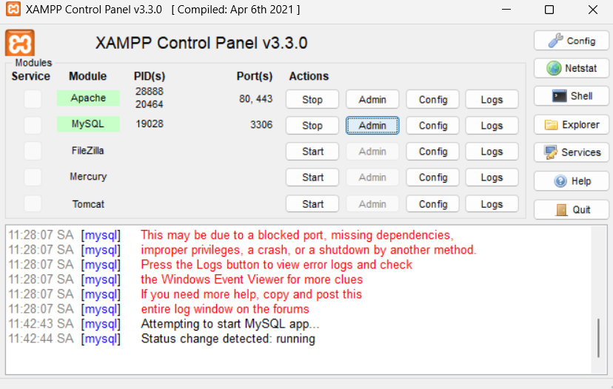

B4: chọn vào “cinema_booking_db” rồi vào phần SQL rồi copy/paste dữ liệu này vào rồi bấm “Go”:
INSERT INTO Movies (Title, Description, PosterUrl, Genre, DurationMinutes, Rating, ReleaseDate)
VALUES
('Inception', 'A mind-bending thriller by Christopher Nolan', '/images/inception.jpg', 'Sci-Fi', 148, 'PG-13', '2010-07-16'),
('Dune: Part Two', 'Epic continuation of the Dune saga', '/images/dune2.jpg', 'Sci-Fi', 165, 'PG-13', '2024-03-01'),
('Interstellar', 'Exploration of space and time', '/images/interstellar.jpg', 'Sci-Fi', 169, 'PG-13', '2014-11-07'),
('The Dark Knight', 'Batman faces the Joker in Gotham', '/images/darkknight.jpg', 'Action', 152, 'PG-13', '2008-07-18'),
('Parasite', 'A dark satire on class and society', '/images/parasite.jpg', 'Drama', 132, 'R', '2019-05-30'),
('Your Name', 'A beautiful anime about time and love', '/images/yourname.jpg', 'Animation', 106, 'PG', '2016-08-26')

INSERT INTO cinemas (Name, Location, Phone)
VALUES
('CGV Vincom Đồng Khởi', 'Quận 1, TP.HCM', '028-3823-4567'),
('Galaxy Nguyễn Du', 'Quận 1, TP.HCM', '028-3923-6789'),
('Lotte Cinema Gò Vấp', 'Quận Gò Vấp, TP.HCM', '028-3989-1234'),
('BHD Star Thảo Điền', 'Quận 2, TP.HCM', '028-3744-5678'),
('Cinestar Hai Bà Trưng', 'Quận 3, TP.HCM', '028-3930-7890');

-- Thêm ghế cho ShowTime ID = 1, 2, 3, 4, 5
-- Mỗi ShowTime có 50 ghế (5 hàng A-E, mỗi hàng 10 ghế)

%%%%%%%%%%%%%%
Tạo dữ liệu cho seats
INSERT INTO seats (SeatNumber, SeatType, Price, IsAvailable, ShowTimeId) VALUES
-- ShowTime 1
('A1', 'Normal', 100000, 1, 1), ('A2', 'Normal', 100000, 1, 1), ('A3', 'Normal', 100000, 1, 1), ('A4', 'VIP', 150000, 1, 1), ('A5', 'VIP', 150000, 1, 1), ('A6', 'Normal', 100000, 1, 1), ('A7', 'Normal', 100000, 1, 1), ('A8', 'Normal', 100000, 1, 1), ('A9', 'Normal', 100000, 1, 1), ('A10', 'Couple', 200000, 1, 1),
('B1', 'Normal', 100000, 1, 1), ('B2', 'Normal', 100000, 1, 1), ('B3', 'VIP', 150000, 1, 1), ('B4', 'VIP', 150000, 1, 1), ('B5', 'VIP', 150000, 1, 1), ('B6', 'VIP', 150000, 1, 1), ('B7', 'Normal', 100000, 1, 1), ('B8', 'Normal', 100000, 1, 1), ('B9', 'Normal', 100000, 1, 1), ('B10', 'Couple', 200000, 1, 1),
('C1', 'Normal', 100000, 1, 1), ('C2', 'Normal', 100000, 1, 1), ('C3', 'VIP', 150000, 1, 1), ('C4', 'VIP', 150000, 1, 1), ('C5', 'VIP', 150000, 1, 1), ('C6', 'VIP', 150000, 1, 1), ('C7', 'Normal', 100000, 1, 1), ('C8', 'Normal', 100000, 1, 1), ('C9', 'Normal', 100000, 1, 1), ('C10', 'Couple', 200000, 1, 1),
('D1', 'Normal', 100000, 1, 1), ('D2', 'Normal', 100000, 1, 1), ('D3', 'VIP', 150000, 1, 1), ('D4', 'VIP', 150000, 1, 1), ('D5', 'VIP', 150000, 1, 1), ('D6', 'VIP', 150000, 1, 1), ('D7', 'Normal', 100000, 1, 1), ('D8', 'Normal', 100000, 1, 1), ('D9', 'Normal', 100000, 1, 1), ('D10', 'Couple', 200000, 1, 1),
('E1', 'Normal', 100000, 1, 1), ('E2', 'Normal', 100000, 1, 1), ('E3', 'Normal', 100000, 1, 1), ('E4', 'Normal', 100000, 1, 1), ('E5', 'Normal', 100000, 1, 1), ('E6', 'Normal', 100000, 1, 1), ('E7', 'Normal', 100000, 1, 1), ('E8', 'Normal', 100000, 1, 1), ('E9', 'Normal', 100000, 1, 1), ('E10', 'Couple', 200000, 1, 1),

-- ShowTime 2
('A1', 'Normal', 100000, 1, 2), ('A2', 'Normal', 100000, 1, 2), ('A3', 'Normal', 100000, 1, 2), ('A4', 'VIP', 150000, 1, 2), ('A5', 'VIP', 150000, 1, 2), ('A6', 'Normal', 100000, 1, 2), ('A7', 'Normal', 100000, 1, 2), ('A8', 'Normal', 100000, 1, 2), ('A9', 'Normal', 100000, 1, 2), ('A10', 'Couple', 200000, 1, 2),
('B1', 'Normal', 100000, 1, 2), ('B2', 'Normal', 100000, 1, 2), ('B3', 'VIP', 150000, 1, 2), ('B4', 'VIP', 150000, 1, 2), ('B5', 'VIP', 150000, 1, 2), ('B6', 'VIP', 150000, 1, 2), ('B7', 'Normal', 100000, 1, 2), ('B8', 'Normal', 100000, 1, 2), ('B9', 'Normal', 100000, 1, 2), ('B10', 'Couple', 200000, 1, 2),
('C1', 'Normal', 100000, 1, 2), ('C2', 'Normal', 100000, 1, 2), ('C3', 'VIP', 150000, 1, 2), ('C4', 'VIP', 150000, 1, 2), ('C5', 'VIP', 150000, 1, 2), ('C6', 'VIP', 150000, 1, 2), ('C7', 'Normal', 100000, 1, 2), ('C8', 'Normal', 100000, 1, 2), ('C9', 'Normal', 100000, 1, 2), ('C10', 'Couple', 200000, 1, 2),
('D1', 'Normal', 100000, 1, 2), ('D2', 'Normal', 100000, 1, 2), ('D3', 'VIP', 150000, 1, 2), ('D4', 'VIP', 150000, 1, 2), ('D5', 'VIP', 150000, 1, 2), ('D6', 'VIP', 150000, 1, 2), ('D7', 'Normal', 100000, 1, 2), ('D8', 'Normal', 100000, 1, 2), ('D9', 'Normal', 100000, 1, 2), ('D10', 'Couple', 200000, 1, 2),
('E1', 'Normal', 100000, 1, 2), ('E2', 'Normal', 100000, 1, 2), ('E3', 'Normal', 100000, 1, 2), ('E4', 'Normal', 100000, 1, 2), ('E5', 'Normal', 100000, 1, 2), ('E6', 'Normal', 100000, 1, 2), ('E7', 'Normal', 100000, 1, 2), ('E8', 'Normal', 100000, 1, 2), ('E9', 'Normal', 100000, 1, 2), ('E10', 'Couple', 200000, 1, 2),

-- ShowTime 3
('A1', 'Normal', 100000, 1, 3), ('A2', 'Normal', 100000, 1, 3), ('A3', 'Normal', 100000, 1, 3), ('A4', 'VIP', 150000, 1, 3), ('A5', 'VIP', 150000, 1, 3), ('A6', 'Normal', 100000, 1, 3), ('A7', 'Normal', 100000, 1, 3), ('A8', 'Normal', 100000, 1, 3), ('A9', 'Normal', 100000, 1, 3), ('A10', 'Couple', 200000, 1, 3),
('B1', 'Normal', 100000, 1, 3), ('B2', 'Normal', 100000, 1, 3), ('B3', 'VIP', 150000, 1, 3), ('B4', 'VIP', 150000, 1, 3), ('B5', 'VIP', 150000, 1, 3), ('B6', 'VIP', 150000, 1, 3), ('B7', 'Normal', 100000, 1, 3), ('B8', 'Normal', 100000, 1, 3), ('B9', 'Normal', 100000, 1, 3), ('B10', 'Couple', 200000, 1, 3),
('C1', 'Normal', 100000, 1, 3), ('C2', 'Normal', 100000, 1, 3), ('C3', 'VIP', 150000, 1, 3), ('C4', 'VIP', 150000, 1, 3), ('C5', 'VIP', 150000, 1, 3), ('C6', 'VIP', 150000, 1, 3), ('C7', 'Normal', 100000, 1, 3), ('C8', 'Normal', 100000, 1, 3), ('C9', 'Normal', 100000, 1, 3), ('C10', 'Couple', 200000, 1, 3),
('D1', 'Normal', 100000, 1, 3), ('D2', 'Normal', 100000, 1, 3), ('D3', 'VIP', 150000, 1, 3), ('D4', 'VIP', 150000, 1, 3), ('D5', 'VIP', 150000, 1, 3), ('D6', 'VIP', 150000, 1, 3), ('D7', 'Normal', 100000, 1, 3), ('D8', 'Normal', 100000, 1, 3), ('D9', 'Normal', 100000, 1, 3), ('D10', 'Couple', 200000, 1, 3),
('E1', 'Normal', 100000, 1, 3), ('E2', 'Normal', 100000, 1, 3), ('E3', 'Normal', 100000, 1, 3), ('E4', 'Normal', 100000, 1, 3), ('E5', 'Normal', 100000, 1, 3), ('E6', 'Normal', 100000, 1, 3), ('E7', 'Normal', 100000, 1, 3), ('E8', 'Normal', 100000, 1, 3), ('E9', 'Normal', 100000, 1, 3), ('E10', 'Couple', 200000, 1, 3),

-- ShowTime 4
('A1', 'Normal', 100000, 1, 4), ('A2', 'Normal', 100000, 1, 4), ('A3', 'Normal', 100000, 1, 4), ('A4', 'VIP', 150000, 1, 4), ('A5', 'VIP', 150000, 1, 4), ('A6', 'Normal', 100000, 1, 4), ('A7', 'Normal', 100000, 1, 4), ('A8', 'Normal', 100000, 1, 4), ('A9', 'Normal', 100000, 1, 4), ('A10', 'Couple', 200000, 1, 4),
('B1', 'Normal', 100000, 1, 4), ('B2', 'Normal', 100000, 1, 4), ('B3', 'VIP', 150000, 1, 4), ('B4', 'VIP', 150000, 1, 4), ('B5', 'VIP', 150000, 1, 4), ('B6', 'VIP', 150000, 1, 4), ('B7', 'Normal', 100000, 1, 4), ('B8', 'Normal', 100000, 1, 4), ('B9', 'Normal', 100000, 1, 4), ('B10', 'Couple', 200000, 1, 4),
('C1', 'Normal', 100000, 1, 4), ('C2', 'Normal', 100000, 1, 4), ('C3', 'VIP', 150000, 1, 4), ('C4', 'VIP', 150000, 1, 4), ('C5', 'VIP', 150000, 1, 4), ('C6', 'VIP', 150000, 1, 4), ('C7', 'Normal', 100000, 1, 4), ('C8', 'Normal', 100000, 1, 4), ('C9', 'Normal', 100000, 1, 4), ('C10', 'Couple', 200000, 1, 4),
('D1', 'Normal', 100000, 1, 4), ('D2', 'Normal', 100000, 1, 4), ('D3', 'VIP', 150000, 1, 4), ('D4', 'VIP', 150000, 1, 4), ('D5', 'VIP', 150000, 1, 4), ('D6', 'VIP', 150000, 1, 4), ('D7', 'Normal', 100000, 1, 4), ('D8', 'Normal', 100000, 1, 4), ('D9', 'Normal', 100000, 1, 4), ('D10', 'Couple', 200000, 1, 4),
('E1', 'Normal', 100000, 1, 4), ('E2', 'Normal', 100000, 1, 4), ('E3', 'Normal', 100000, 1, 4), ('E4', 'Normal', 100000, 1, 4), ('E5', 'Normal', 100000, 1, 4), ('E6', 'Normal', 100000, 1, 4), ('E7', 'Normal', 100000, 1, 4), ('E8', 'Normal', 100000, 1, 4), ('E9', 'Normal', 100000, 1, 4), ('E10', 'Couple', 200000, 1, 4),

-- ShowTime 5
('A1', 'Normal', 100000, 1, 5), ('A2', 'Normal', 100000, 1, 5), ('A3', 'Normal', 100000, 1, 5), ('A4', 'VIP', 150000, 1, 5), ('A5', 'VIP', 150000, 1, 5), ('A6', 'Normal', 100000, 1, 5), ('A7', 'Normal', 100000, 1, 5), ('A8', 'Normal', 100000, 1, 5), ('A9', 'Normal', 100000, 1, 5), ('A10', 'Couple', 200000, 1, 5),
('B1', 'Normal', 100000, 1, 5), ('B2', 'Normal', 100000, 1, 5), ('B3', 'VIP', 150000, 1, 5), ('B4', 'VIP', 150000, 1, 5), ('B5', 'VIP', 150000, 1, 5), ('B6', 'VIP', 150000, 1, 5), ('B7', 'Normal', 100000, 1, 5), ('B8', 'Normal', 100000, 1, 5), ('B9', 'Normal', 100000, 1, 5), ('B10', 'Couple', 200000, 1, 5),
('C1', 'Normal', 100000, 1, 5), ('C2', 'Normal', 100000, 1, 5), ('C3', 'VIP', 150000, 1, 5), ('C4', 'VIP', 150000, 1, 5), ('C5', 'VIP', 150000, 1, 5), ('C6', 'VIP', 150000, 1, 5), ('C7', 'Normal', 100000, 1, 5), ('C8', 'Normal', 100000, 1, 5), ('C9', 'Normal', 100000, 1, 5), ('C10', 'Couple', 200000, 1, 5),
('D1', 'Normal', 100000, 1, 5), ('D2', 'Normal', 100000, 1, 5), ('D3', 'VIP', 150000, 1, 5), ('D4', 'VIP', 150000, 1, 5), ('D5', 'VIP', 150000, 1, 5), ('D6', 'VIP', 150000, 1, 5), ('D7', 'Normal', 100000, 1, 5), ('D8', 'Normal', 100000, 1, 5), ('D9', 'Normal', 100000, 1, 5), ('D10', 'Couple', 200000, 1, 5),
('E1', 'Normal', 100000, 1, 5), ('E2', 'Normal', 100000, 1, 5), ('E3', 'Normal', 100000, 1, 5), ('E4', 'Normal', 100000, 1, 5), ('E5', 'Normal', 100000, 1, 5), ('E6', 'Normal', 100000, 1, 5), ('E7', 'Normal', 100000, 1, 5), ('E8', 'Normal', 100000, 1, 5), ('E9', 'Normal', 100000, 1, 5), ('E10', 'Couple', 200000, 1, 5);

